**DAILY ONLINE ACTIVITIES SUMMARY**

|  |  |  |  |  |  |  |  |  |
| --- | --- | --- | --- | --- | --- | --- | --- | --- |
| **Date:** | **22/05/2020** | | | | | **Name:** | **Albin Francis** | |
| **Sem & Sec** | **8th sem,A** | | | | | **USN:** | **4AL16CS008** | |
| **Online Test Summary** | | | | | | | | |
| **Subject** | | **BDA** | | | | | | |
| **Max. Marks** | | **40** | | **Score** | | | **29** | |
| **Certification Course Summary** | | | | | | | | |
| **Course** | **Getting Started To Hadoop** | | | | | | | |
| **Certificate Provider** | | | **GreatLearning** | | **Duration** | | | **33mins** |
| **Coding Challenges** | | | | | | | | |
| **Problem Statement: Find the number that is missing from the array containing n**  **distinct numbers taken from 0,1,2...n** | | | | | | | | |
| **Status: Solved** | | | | | | | | |
| **Uploaded the report in Github** | | | | | **Yes** | | | |
| **If yes Repository name** | | | | | **albinfrancis008** | | | |
| **Uploaded the report in slack** | | | | | **Yes** | | | |

Online Test Details: (Attach the snapshot and briefly write the report for the same)

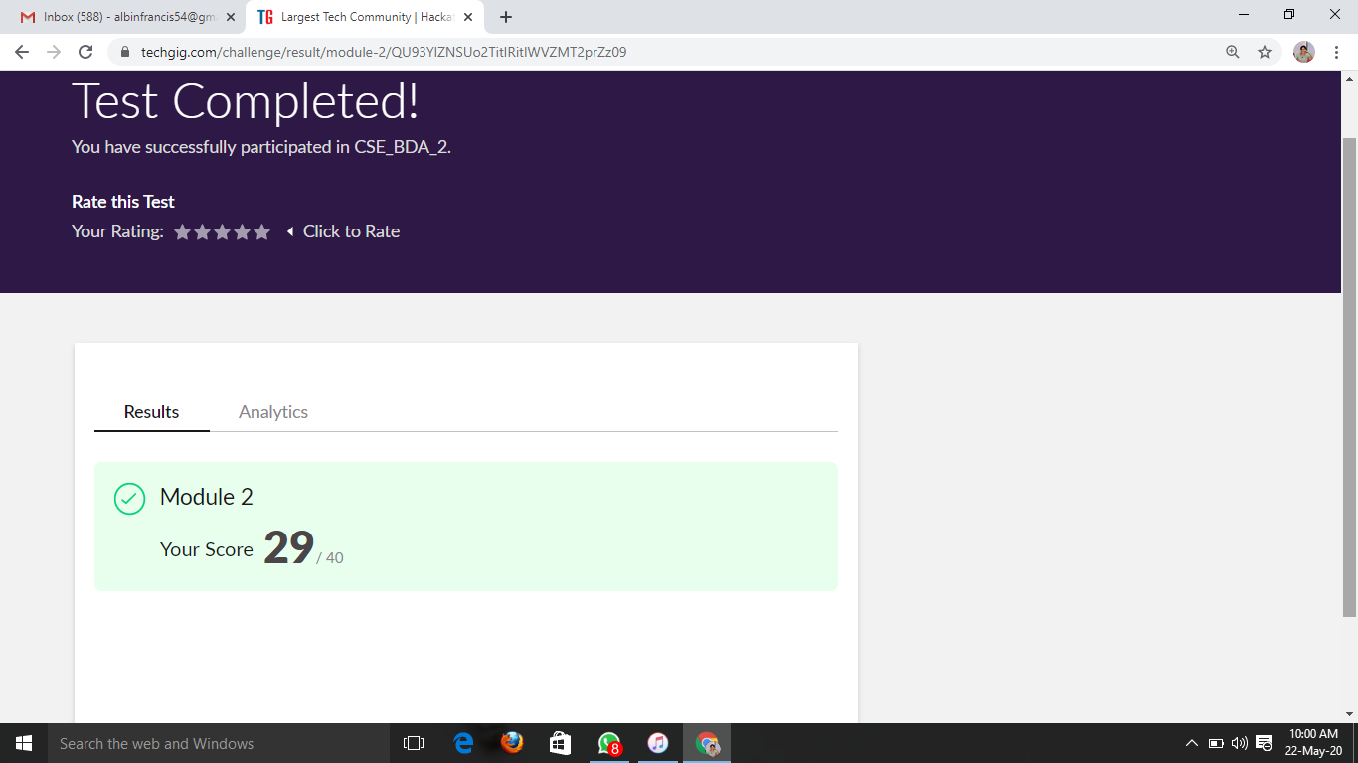

Certification Course Details: (Attach the snapshot and briefly write the report for the same)

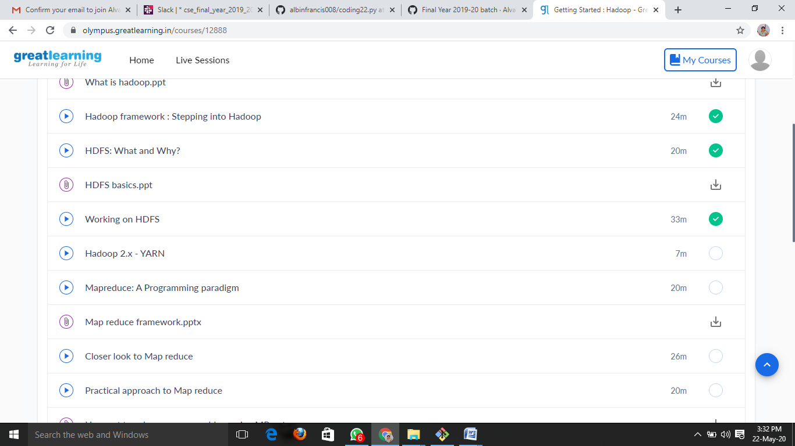

WORKING ON HDFS:-

* Installation of Vmware Workstation for Hadoop in linux
* Commands to use hadoop in linux
* And commands like:
  + - * To check the version of Hadoop.
      * List all the files/directories for the given hdfs destination path.
      * Displays free space at given hdfs destination
      * HDFS Command to create the directory in HDFS.
      * HDFS Command to copy files from hdfs to the local file system.

Coding Challenges Details: (Attach the snapshot and briefly write the report for the same)

Find the number that is missing from the array containing n distinct numbers taken from 0,1,2...n

def missNo(x):

l=len(x)

maxs=max(x)

mins=min(x)

for i in range(0,l):

if mins not in x and mins<=maxs:

return mins

else:

mins+=1

y=[20,19,18,17,16,15,13]

m=(missNo(y))

print("missing number is",m)